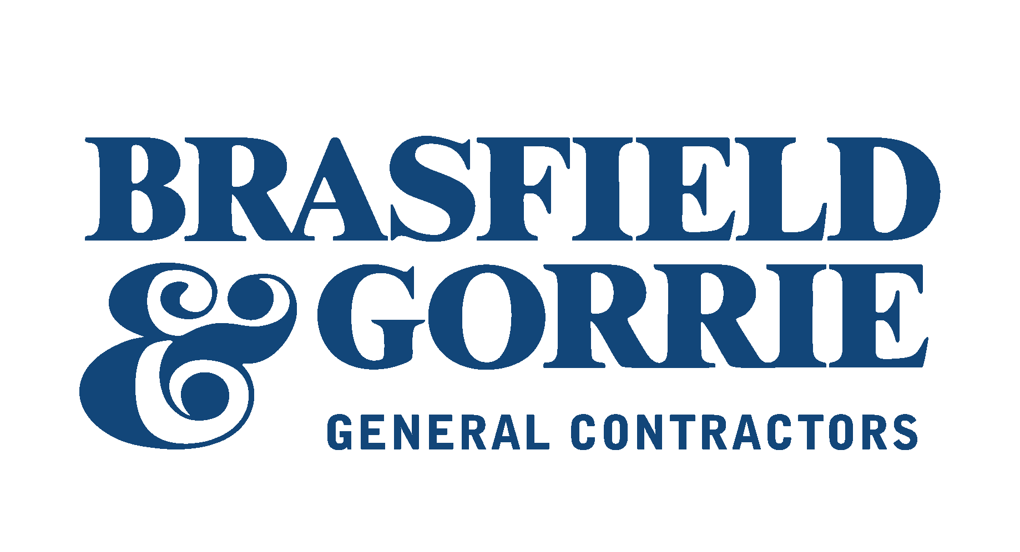

Contractor’s Qualification Statement

General Description of Work:

Please answer the following questions in the order listed. Include the questions with your response in the desired format in which you wish to present your information.

The Undersigned certifies that the information provided herein is true and sufficiently complete so as not to be misleading.

SUBMITTED TO: Brasfield & Gorrie, LLC

Company Name
Employer Identification Number
Prior Experience with B&G
(if yes, provide year of last project)
Street address
City, State, Zip Code
(street address only)
Post Office Box
City, State, Zip Code
(post office box only)
Phone No
Fax No
Contact
Email Address
Company Web Address
Submitted By
Principal Office
TYPE OF WORK
Subcontractor
Vendor
Manufacturer
Consultant
Other

TYPE OF COMPANY
Corporation
Partnership
Individual
Joint Venture
Other

- GENERAL INFORMATION

There is no expressed or implied obligation for Brasfield & Gorrie to reimburse responding firms for any expenses incurred in preparing qualifications in response to this request.

- ORGANIZATION

  - How many years has your organization been in business as a Subcontractor?

  - How many years has your organization been in business under its present business name?

    - Under what other or former names has your organization operated?

- SAFETY

3.1 Describe your safety program. Provide any information on any particular safety issues you would anticipate on this project and how your company would handle them.

3.2 Provide worker compensation experience modification rate for the past five (5) years:

Year | Rate | Carrier
2016
2015
2014
2013
2012

3.3 Provide number of OSHA Citations for the past five (5) years:

Year | Citations | Reasons
2016
2015
2014
2013
2012

- LICENSING

List jurisdictions and trade categories in which your organization is legally qualified to do business, and indicate registration or license numbers, if applicable. Please use the attached checklist to complete.

  - Please check each of the following that applies to your organization:
(List the Certify Agency and the Certification No.)

4.2.1 |  | Minority
4.2.2 |  | Woman Owned
4.2.3 |  | Disadvantaged
4.2.4 |  | Veteran
4.2.5 |  | Small Business
4.2.6 |  | Other (specify)

- EXPERIENCE

  - List the categories of work that your organization normally self performs:

  - Claims and Suits.
(If the answer to any of the questions below is yes, please attach details.)

    - Has your organization ever failed to complete any work awarded to it?

    - Are there any judgments, claims, arbitration proceedings or suits pending or outstanding against your organization or its officers?

    - Has your organization filed any lawsuits or requested arbitration with regard to construction contracts within the last five (5) years?

  - Within the last five (5) years, has any officer or principal of your organization ever been an officer or principal of another organization when it failed to complete a construction contract? (If the answer is yes, please attach details.)

  - List major construction projects your organization currently has in progress:

project name: | general contractor: | contract amount:
owner: | general contractor contact: | % complete:
arch: | general contractor phone: | scheduled completion date:

project name: | general contractor: | contract amount:
owner: | general contractor contact: | % complete:
arch: | general contractor phone: | scheduled completion date:

project name: | general contractor: | contract amount:
owner: | general contractor contact: | % complete:
arch: | general contractor phone: | scheduled completion date:

project name: | general contractor: | contract amount:
owner: | general contractor contact: | % complete:
arch: | general contractor phone: | scheduled completion date:

project name: | general contractor: | contract amount:
owner: | general contractor contact: | % complete:
arch: | general contractor phone: | scheduled completion date:

  - State total value of work under contract and work under contract remaining to be completed to date:

  - List the major projects your organization has completed in the past five (5) years:

project name: | general contractor: | job amount:
owner: | general contractor contact: | date of completion:
arch: | general contractor phone: | work performed:

project name: | general contractor: | job amount:
owner: | general contractor contact: | date of completion:
arch: | general contractor phone: | work performed:

project name: | general contractor: | job amount:
owner: | general contractor contact: | date of completion:
arch: | general contractor phone: | work performed:

project name: | general contractor: | job amount:
owner: | general contractor contact: | date of completion:
arch: | general contractor phone: | work performed:

project name: | general contractor: | job amount:
owner: | general contractor contact: | date of completion:
arch: | general contractor phone: | work performed:
* Attach any additional projects.

  - List your company’s annual volume for the past five (5) years:

Year Volume
2016
2015
2014
2013
2012

  - List your company’s largest contract to date:
Job Name:
Value:
Date Completed:

  - Please enter the project value range for the scope of work that your company is interested in pursuing.
    - Project Size min $
    - Project Size max $

- REFERENCES

  - Trade References:
firm: | address: | phone:
contact: | city, state, zip:

firm: | address: | phone:
contact: | city, state, zip:

firm: | address: | phone:
contact: | city, state, zip:

  - Bank References:
bank: | address: | phone:
contact: | city, state, zip:

bank: | address: | phone:
contact: | city, state, zip:

Please provide a current letter from the Surety Company and ask that the surety agent specifically certify any open performance bond claims and length of relationship.

  - State the name and rating of your bonding company.
surety company: | address: | phone:
contact: | city, state, zip: | rating:

  - State the name of your bonding agent and your bonding capacity.
bonding agent: | address: | phone:
contact: | city, state, zip: | total aggregate bonding capacity:
 |  | single project bonding capacity:

- PLEASE FURNISH THE FOLLOWING ADDITIONAL INFORMATION:

  - List total number of field employees that your company currently employs.

  - List total number of office employees that your company currently employs.

  - What percentage of work does your company perform with its own forces?

- SIGNATURE

- Dated at this day of , 2016

Name of Organization:

By:

Title:

10.2 Mr./Ms. being duly sworn deposes and says that the information provided herein is true and sufficiently complete so as not to be misleading.

Subscribed and sworn before me this day of , 2016

Notary Public:

My Commission Expires:

Attachment A: CSI Codes (Page 1 Of 3)
Please Mark All Scopes Of Work You Perform
 | 011500 | Insurance & Bonding |  | 061300 | Heavy Timber Fabricators & Ints.
 | 013100 | GC's & Project Management |  | 061753 | Wood Trusses
 | 013200 | Reprographics & Plan Room |  | 062000 | Finish Carpentry & Woodwork
 | 013425 | Landscapre & Hardscape Design |  | 064100 | Architectural Wood Casework
 | 014523 | Material Testing |  | 065000 | Plastic Fabrication
 | 015416 | Material & Personnel Hoists |  | 070000 | Thermal & Moisture Protection
 | 015419 | Cranes |  | 071000 | Waterproofing & Sealants
 | 015423 | Scaffolding |  | 072119 | Spray Foam Insulation
 | 015430 | Equipment Rental |  | 072126 | Blown Insulation
 | 017423 | Final Cleaning |  | 072400 | Exterior Insulation & Finish System
 | 018500 | Safety Equipment |  | 073100 | Shingle & Shake Roofing
 | 019501 | Dump Truck Services |  | 074100 | Metal Roofing
 | 022100 | Professional Surveying |  | 074200 | Metal & Composite Wall Panels
 | 024100 | Demolition |  | 074600 | Siding
 | 028000 | Hazardous Material Remediation |  | 075200 | Modified Bit Roofing
 | 030500 | Turn Key Concrete Contractors |  | 075400 | Mebrane Rfg. (TPO, PVS, EPDM)
 | 032100 | Concrete Reinforcing Material Suppliers |  | 077600 | Roof Paver Systems
 | 032101 | Concrete Reinforcing Installers |  | 078100 | Fireproofing
 | 033000 | Concrete Material Suppliers |  | 078400 | Fire Stopping
 | 033500 | Concrete Finishers |  | 079500 | Expansion Control
 | 033716 | Concrete Pumping |  | 081000 | Standard Doors, Frames, & Hdwr.
 | 033800 | Post Tensioned Material Suppliers |  | 081001 | Door & Hardware Installation
 | 034100 | Precast Structural Shapes |  | 083100 | Access Doors
 | 034500 | Precast Architectual Concrete |  | 083463 | Detention Doors, Frames, & Hdwr.
 | 034713 | Concrete Tilt Wall |  | 084300 | Storefront
 | 034800 | Caststone Suppliers |  | 084400 | Curtainwall
 | 042000 | Masonry |  | 084500 | Translucent Panel Systems
 | 051200 | Structural Steel |  | 085000 | Prehung Windows
 | 051201 | Steel Erection |  | 086000 | Skylights
 | 054400 | Light Gage Metal Trusses |  | 088000 | Glass & Glazing
 | 054500 | Unistrut |  | 089100 | Louvers & Vents
 | 055100 | Metal Stairs |  | 092000 | Metal Studs & Drywall
 | 055200 | Miscellaneous Steel |  | 092001 | Drywall Material Suppliers
 | 055213 | Pipe & Tube Railings |  | 092400 | Gypsum Plaster
 | 055900 | Metal Specialties (Balconies / Gratings) |  | 092423 | Stucco
 | 057314 | Ornamental Railings |  | 092713 | GFCP & GFRC Fabrication
 | 060140 | Wood Restoration & Refinishing |  | 093100 | Ceramic, Porcelain, & Quarry Tile
 | 060500 | Lumber Suppliers |  | 095100 | Acoustical Ceilings
 | 061053 | Rough Carpentry Subcontractors |  | 095413 | Metal Ceilings
 | 061100 | Wood Frame Contractors |  | 095416 | Luminous Ceilings
Attachment A: CSI Codes (Page 2 Of 3)
Please Mark All Scopes Of Work You Perform
 | 096201 | Polished Concrete Floors |  | 111319 | Loading Dock Lifts
 | 096300 | Stone Flooring |  | 111400 | Pedestrian Control Equipment
 | 096400 | Wood Flooring |  | 111600 | Vaults and Safes
 | 096500 | Resilient Flooring |  | 112400 | Window Washing Equipment
 | 096600 | Terrazzo Flooring |  | 113100 | Residential Appliances
 | 096713 | Elastomeric Liquid Flooring |  | 114400 | Food Service Equipment
 | 096723 | Resinous Flooring |  | 115100 | Library Equipment
 | 096766 | Fluid-Applied Athletic Flooring |  | 115213 | Audio Visual Equipment
 | 096800 | Carpeting |  | 115300 | Laboratory Equipment
 | 096900 | Access Flooring |  | 116813 | Playground Equipment
 | 097200 | Wall Coverings |  | 116833 | Athletic Field Equipment
 | 097500 | Stone Facing |  | 117000 | Healthcare Equipment
 | 097723 | Fabric Wrapped Panels |  | 118213 | Solid Waste Bins
 | 097800 | Wall Panels |  | 122100 | Window Blinds
 | 098400 | Acoustical Panels |  | 123100 | Casework
 | 099100 | Painting |  | 123600 | Countertops
 | 101100 | Visual Display Boards |  | 124813 | Entrance Mats
 | 101400 | Int. & Ext. Fabricated Signage |  | 125100 | Office Furniture
 | 101416 | Interior Room Signage |  | 126100 | Fixed Audience Seating
 | 102100 | Compartments (Toilet, Shower, etc) |  | 129323 | Benches, Trash Recp., & Bicycle Rks.
 | 102213 | Wire Mesh Partitions |  | 133419 | Pre-Engineered Metal Buildings
 | 102219 | Demountable Partitions |  | 134900 | Radio and Radiation Protection
 | 102233 | Operable Partitions |  | 131100 | Swimming Pools
 | 102500 | Service Walls |  | 131200 | Fountains
 | 102600 | Wall Protection |  | 131300 | Aquariums
 | 102800 | Toilet and Bath Specialties |  | 132000 | Special Purpose Rooms
 | 103200 | Fireplaces |  | 141000 | Dumbwaiters
 | 104400 | Fire Extinguishers |  | 142000 | Elevators
 | 105100 | Lockers |  | 143000 | Escalators and Moving Walks
 | 105500 | Postal Boxes |  | 144000 | Wheel Chair Lifts
 | 105613 | Shelving |  | 149100 | Chutes
 | 105626 | Motorized Mobile Strg. Shelving |  | 149200 | Pneumatic Tube Systems
 | 107113 | Exterior Sun Control Devices |  | 210000 | Fire Suppression
 | 107313 | Fabric Awnings |  | 221000 | Plumbing
 | 107316 | Metal Canopies & Walkway Covers |  | 221005 | Plumbing Equip. & Material Supp.
 | 107343 | Exterior Pre-Fabricated Shelters |  | 236000 | HVAC Systems - 2, 3, & 4
 | 111100 | Vehicle Service Equipment |  | 237000 | HVAC Sys. - Pkg., DX, & Split Sys.
 | 111200 | Parking Control Equipment |  | 260000 | Electrical
Attachment A: CSI Codes (Page 3 Of 3)
Please Mark All Scopes Of Work You Perform
 | 260005 | Electrical Equip. & Material Suppliers |  | 335100 | Natural Gas Distribution
 | 264100 | Lightning Protection |  | 337000 | Electrical Utility Distribution
 | 264200 | Cathodic Protection |  | 338000 | Communication Utility Distribution
 | 265000 | Lighting Suppliers |  | 341100 | Rail Track
 | 270000 | Communications / Low Voltage / Telecom |  | 344113 | Traffic Signals
 | 271000 | Structured Cabling |  | 347100 | Road Construction
 | 274117 | Board & Conference Room AV Sys. |  | 347113 | Vehicular Guard Rails & Spec
 | 281300 | Access Control Systems |  | 400005 | Process Piping
 | 281600 | Security Systems |  | 480000 | Electrical Power Generation Division
 | 282300 | Video Surveillance Systems |  | 481400 | Solar Energy Electrical Pwr. Gen. Eq.
 | 283000 | Fire Alarm Systems
 | 312000 | Site Grading & Earthwork
 | 312316 | Blasting
 | 312319 | Dewatering
 | 313100 | Soil Treatment
 | 313400 | Soil Stabilization / Reinforcement
 | 314100 | Shoring
 | 315100 | Soil & Rock Anchors
 | 315200 | Cofferdams
 | 316200 | Driven Piles
 | 316300 | Auger Cast Piles
 | 316326 | Drilled Caissons / Piers
 | 316613 | Rammed Aggregate Piers
 | 321216 | Asphalt Paving
 | 321313 | Concrete Paving
 | 321413 | Concrete or Brick Pavers
 | 321613 | Curb and Gutter
 | 321623 | Sidewalks
 | 321723 | Pavement Markings
 | 323113 | Chainlink Fences
 | 323400 | Fabricated Bridges
 | 328000 | Irrigation
 | 329000 | Landscaping and Planting
 | 329200 | Grassing
 | 331000 | Domestic Water & Fire Dist.
 | 332000 | Wells
 | 333000 | Sanitary Sewer
 | 334000 | Storm Drainange
 | 334500 | Storm Drainange Piping

Attachment B: State Licenses Please mark all states in which you are licensed.
NATIONWIDE
Alaska - AK
Alabama - AL
Arkansas - AR
Arizona - AZ
California - CA
Colorado - CO
Connecticut - CT
District of Columbia - DC
Delaware - DE
Florida - FL
Georgia - GA
Hawaii - HI
Iowa - IA
Idaho - ID
Illinois - IL
Indiana - IN
Kansas - KS
Kentucky - KY
Louisiana - LA
Massachusetts - MA
Maryland - MD
Maine - ME
Michigan - MI
Minnesota - MN
Missouri - MO
Mississippi - MS
Montana - MT
North Carolina - NC
North Dakota - ND
Nebraska - NE
New Hampshire - NH
New Jersey - NJ
New Mexico - NM
Nevada - NV
New York - NY
Ohio - OH
Oklahoma - OK
Oregon - OR
Pennsylvania - PA
Rhode Island - RI
South Carolina - SC
South Dakota - SD
Tennessee - TN
Texas - TX
Utah - UT
Virginia - VA
Vermont - VT
Washington - WA
Wisconsin - WI
West Virginia - WV
Wyoming - WY

