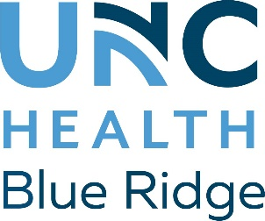

Contact: Danette Brackett
Danette.brackett@blueridgehealth.org
(828) 580-5690

UNC Health Blue Ridge
To Host Groundbreaking Ceremony
for New $38.3 Million Cancer Center

VALDESE, N.C. (May 11, 2022) - UNC Health Blue Ridge is embarking on a period of growth and expansion program called Project Forward: Your Hospital, Your Future. On the Valdese campus to the left of the hospital, Project Forward calls for a new $38.3 million cancer center as part of a 34,272-square-foot addition and renovation plan.
A groundbreaking ceremony is set for Wednesday, May 18, at 11 a.m.
The new cancer center will include an infusion therapy and treatment area; medical and radiation oncology exam, consultation, and treatment rooms; and two new linear accelerators. There will be dedicated space for education, support, and group therapy.
Visitors and patients to the Valdese campus are asked to use caution and follow signs as some departments have had to temporarily move.
Brasfield & Gorrie, one of the nation’s largest privately-held construction firms, is the general contractor for the project. “Brasfield & Gorrie works every day to build strong communities, and it’s an honor to do so through our work with UNC Health Blue Ridge. Cancer has affected nearly everyone in some way, and the new cancer center will be a state-of-the-art tool in the fight against this terrible disease,” said Brasfield & Gorrie Regional Vice President and Division Manager Michael Byrd.
Also part of the construction project is the healthcare design firm DLR Group and the engineering and surveying firm McKim & Creed.
A second groundbreaking later this summer will take place on the Morganton campus where a six-story tower will be built on the right-hand side of the hospital. Brasfield & Gorrie will also be the general contractor for this project. The 220,560-square-foot addition will include a new Emergency Department, Intensive Care, Progressive Care Unit, and rooftop helipad. Three of the floors will be built but remain empty for future expansion.
“Since the summer of 2020, we have been working on an aggressive and forward-thinking Master Facility Plan,” said Kathy Bailey, President and CEO of UNC Health Blue Ridge. “COVID may have put the actual implementation on hold then, but we are moving forward today with plans that will affect your future and the hospital system’s future.”
Over the next two years, UNC Health Blue Ridge will invest $156 million into these construction projects. Construction in Valdese is expected to wrap up in August 2023.
###
About UNC Health Blue Ridge
UNC Health Blue Ridge (www.unchealthblueridge.org) is a not-for-profit community healthcare system, providing advanced healthcare and wellness services from more than 40 locations across a three-county region of Western North Carolina. The system includes one hospital with two locations, a wellness center, and a continuing care retirement community. Nearly 120 primary care physicians, physician specialists and extenders in the Blue Ridge Medical Group combine with other physicians on the Medical Staff to serve patients in the region. UNC Health Blue Ridge provides graduate medical education programs for medical school graduates and students in osteopathic medicine. UNCBR is affiliated with UNC Health System (www.unchealthcare.org), a not-for-profit integrated health care system owned by the state of North Carolina and based in Chapel Hill
About Brasfield & Gorrie

Founded in 1964, Brasfield & Gorrie is one of the nation’s largest privately held construction firms, providing general contracting, design-build, and construction management services for a wide variety of markets. We are skilled in construction best practices, including virtual design and construction, integrated project delivery, and Lean construction, but we are best known for our preconstruction and self-perform expertise and exceptional client service. Brasfield & Gorrie has 13 offices and more than 3,200 employees. Our 2021 revenues were $4.2 billion. Engineering News-Record ranks Brasfield & Gorrie 22nd among the nation’s “Top 400 Contractors” for 2021. Brasfield & Gorrie is ENR Southeast's 2021 Contractor of the Year.
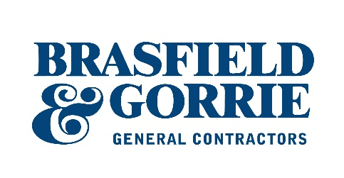

About DLR Group
DLR Group is an integrated design firm delivering architecture, engineering, interiors, planning, and building optimization for new construction, renovation, and adaptive reuse. Our promise is to elevate the human experience through design. This promise inspires sustainable design for a diverse group of public and private sector clients, local communities, and our planet. DLR Group is 100 percent employee-owned and fully supports the initiatives and goals of the 2030 Challenge, and is an initial signatory to the China Accord and the AIA 2030 Commitment.

About McKim & Creed
McKim & Creed is an award-winning, employee-owned engineering and surveying firm with more than 700 staff members in offices throughout the U.S. McKim & Creed is ranked among the top 160 design firms in the U.S. by Engineering News-Record. McKim & Creed specializes in airborne and mobile LiDAR/scanning; unmanned aerial systems; subsurface utility engineering; hydrographic and conventional surveying services; civil, environmental, mechanical, instrumentation, plumbing, and structural engineering; and industrial design-build services for the energy, transportation, government, land development, healthcare, industrial and water industries. www.mckimcreed.com.

